# SQL

1. What is SQL?

* SQL - Structured Query Language
  + For storing, manipulating, and retrieving stored data from relational database.
    - Relational Database – a collection of data items with pre-defined relationships between them. These items are organized as a set of tables with columns and rows. Tables are used to hold info about objects to the represented in the database.
  + SQL is used in relational database management systems like MySQL, MS access, Oracle, Sybase, Informix, postgres and SQL server.
  + Access to data
  + Allows to describe the data
  + Allows to define data in database and manipulate it.
  + Allows to embed with other langs using SQL modules, libraries & pre-compliers
  + Allows to create and drop databases and tables
  + Allows to create view, stored procedure, functions in a database
  + Allows to set permissions on tables, procedures and views

1. Commands:

* DDL- Data Definition Language:
  + CREATE – Create new tables, a view of tables or other objects
  + ALTER – Modifies an existing database object, such as a table
  + DROP – Deletes an entire table, a view of a table or other objects
* DML - Data Manipulation Language:
  + INSERT – Creates a record
  + UPDATE – Modifies records
  + DELETE – Deletes records
* DCL - Data Control Language:
  + GRANT- Gives a privilege to user
  + REVOKE – Takes back privilege granted from user
* DQL - Data Query Language:
  + SELECT - Retrieves certain records from one or more tables

1. RDBMS?

* Relational Database Management System- basis for SGL
* Tables, Fields, Records/rows, Columns, Null

1. SQL Constraints:

* NOT NULL

* DEFAULT:



* UNIQUE



* PRIMARY KEY:



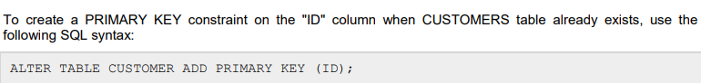



* FOREIGN:

* CHECK:



